Donation by Check Form
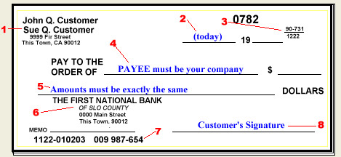
Today’s Date: ___________________________ Amount of Donation/Check: $__________________________

Last Name: _______________________ Middle Name: ________________ First Name: __________________
Street Address: ________________________________________ Apt #: ___________________(If applicable)
City: _____________________ Zip Code: _______________________State:___________________
Email Address: ____________________________ Contact Phone: ____________________________________

Signature: _______________________________________ Date:_________________________________

Note: Please make check payable to USA-Nepal Community Network Outreach Project Network (UNCON)

